Global Multi-Hazard Climate Disaster Forecasting Using Climate and Anthropogenic Indicators with Attention-Based LSTM
Shaik Abdul Rasheed  Department Of Computer Science  Lovely Professional University  India  shaikabdulrahseedchitty@gmail.com  ORCID:- 0009-0003-6326-4556 | Manish Choudhury  Department Of Computer Science  Lovely Professional University  India  choudhurymanish15@gmail.com  ORCID:- 0009-0003-8800-0039 | Somesh Verma  Department Of Computer Science  Lovely Professional University  India  someshverma6009@gmail.com  ORCID:- 0009-0004-6211-8634

Karan Kumar Das
Delivery and Student Success
upGrad Education Pvt. Ltd
Bangalore, Karnataka, India
karandas4643@gmail.com
ORCID:- 0009-0005-0088-4306

Abstract— Predicting multiple hazards is a crucial part of environmental monitoring and disaster risk assessment. This work, presents an attention-based LSTM model for time-series data-based prediction of various disasters, such as floods, droughts, landslides, storms, and wildfires. The data came from databases on climate change and the International Monetary Fund. We combined pertinent datasets to create a comprehensive multi-hazard dataset that includes country-wise disaster occurrences after conducting extensive preprocessing on datasets such as climate disasters, CO concentration, country climate disaster, forest and carbon, land cover account, sea level, and surface temperature. In order to improve feature selection and capture long-range dependencies in sequential data, the proposed model makes use of an attention mechanism. This model includes important environmental and land-use variables that are crucial for disaster prediction, including sea level values, artificial surfaces, land cover indices, inland water bodies, permanent snow and glaciers, carbon stocks in forests, the index of carbon stocks, and forest extinction land area for each country from 1992 to 2020. The model errors are calculated using RMSE and MAE metrices to evaluate the performance during the training phase by comparing actual and anticipated outcomes. The attention-based LSTM model performs better in terms of prediction accuracy than both statistical and conventional LSTM approaches, according to experimental data. The results highlight how well deep learning can comprehend intricate environmental relationships, offering a strong foundation for disaster management organizations and governments to successfully reduce the occurrences of many hazards.
Keywords— Multihazard prediction, attention-based LSTM, time series forecasting, disaster risk assessment, environmental monitoring, deep learning.

Introduction
Anthropogenic activity and climate change have greatly increased the frequency and intensity of natural disasters around the planet. Significant socioeconomic and environmental harm is caused by natural disasters such floods, droughts, storms, landslides, and wildfires, which is why disaster risk assessment and early warning systems are of utmost importance worldwide. Large volumes of anthropogenic and environmental data must be analyzed in order to find trends and connections between different variables in order to predict these catastrophes. Numerous time-series forecasting methods, such as statistical models, conventional machine learning algorithms, and deep learning techniques, have been investigated for the prediction of climatic disasters. For time-series forecasting statistical models like Exponential Smoothing and Autoregressive Integrated Moving Average have been widely utilized. These models, however, are not appropriate for capturing intricate, nonlinear relationships between climate indicators because they assume linear dependencies in the data.
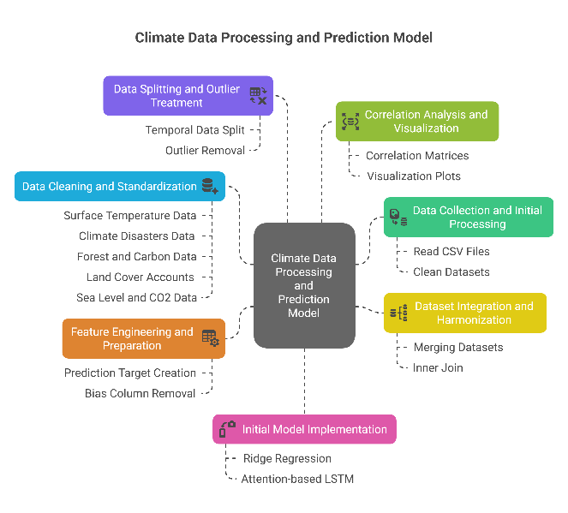
For catastrophe predicting tasks traditional machine learning techniques has been used. Although these models are quite good at handling tabular data, their proficiency in forecasting protracted climate trends is inadequate since they are not built to capture sequential relationships.
In time-series forecasting, deep learning models such as RNNs and LSTM networks have turned out to be perform better. For long-term dependencies, standard RNNs are useless due to vanishing gradient issues. In order to address this problem, LSTM networks use gated mechanisms (forget, input, and output gates), which enable them to save pertinent data throughout lengthy sequences.

Why Use LSTM to Predict Climate Disaster?
- Because of its capacity to efficiently model sequential data while tackling important time-series forecasting issues
- Long-Term Dependency Handling: IN contrast to conventional RNNs, LSTMs are able to retain details over prolonged time, which is crucial for climate forecasting since historical environmental trends affect the likelihood of future disasters.
- Nonlinear Relationship Modeling: Complex, nonlinear connections are present in climate indicators. Compared to machine learning techniques that rely on manufactured features or linear models like ARIMA, LSTM networks are better able to capture these complex interactions
- Adaptive Learning of Temporal Patterns: LSTMs are well-suited to changing climatic circumstances and seasonality in disaster occurrences since they dynamically modify their memory based on observable patterns.
- Scalability and Generalization: LSTMs are useful for worldwide disaster predicting applications because they can be trained on massive datasets from many sources and generalize effectively to various time periods and geographical locations.

When working with high-dimensional climate data, LSTMs still struggle to choose the most pertinent characteristics, despite their strong performance in time-series forecasting. In order to overcome this, we incorporate an attention mechanism that improves anthropogenic and environmental data. This attention-based LSTM model is promising tool for disaster risk assessment and mitigation measures since it increases the interpretability and accuracy of climatic disaster forecasts.

LITERATURE SURVEY
Considerable research emphasis has been placed on emerging technologies for natural disaster forecasting, with machine learning algorithms especially deep learning at the forefront. This section provides a comprehensive review of seminal work that has contributed to this growing field of study.
G. Mahesh Vardhan Reddy[1] classified satellite photos that corresponded to various natural calamities, such as floods and wildfires, using a variety of CNN architectures, include MobileNet. The research highlights the potential of image-based deep learning models with MobileNet’s excellent classification accuracy. Its dependence on static image data, which misses sequential patterns and is unable to record how disasters change overtime is its drawback.
J. MarkElfric[2]suggested a deep learning based system for classifying disasters that uses various data sources, such as social media posts and satellite photos. This approach is useful for detecting disasters in real time, but it ignores forecasting and temporal dependencies, and its classification-only focus makes it inappropriate for disaster prediction in the future.
Yu Wang[3] suggests a decision-support tool driven by AI for evaluating weather hazards. The system lacks real-time forecasting capabilities and deep learning integration for dynamic environmental modelling, despite being useful for scenario-based planning and risk mitigation. It is built on simple AI models and rules.
Y Song[4] investigated the use of CNNs, RNNs and hybrid architectures for earthquake prediction and detection and found that deep learning outperforms conventional techniques in capturing complex seismic patterns. However, the exploration of multi-model data integration and model transparency-problems that attention mechanisms can solve remains limited to earthquakes.
P. Shetty[5] analyzed several machine learning and deep learning methods used in disaster prediction in a meta-analysis. According to the disaster type and data utilized, this evaluation classifies methodologies, showing a slow transition from traditional models to deep learning techniques like CNNs and LSTMs. Notwithstanding its extensive reach, the review shows a deficiency models and draws attention mechanisms that may improve feature selection and interpretability in complex situations.
Nokshi[6] presented a theoretical summary of the effects of climate change and highlights the necessity of integrating anthropogenic and natural components in climate modelling, as well as the significance of combining a variety of indicators for thorough modelling.
G. Sharma[7] focuses on improving emergency response rather than predicting and investigates the use of real-time weather data analysis in disaster management systems. Despite the significant use of real-time data, the methodology’s applicability for long-term disaster predictions is limited since its lacks depth in predictive modelling and does not make use of temporal deep learning methodologies.
B.Yang[8] compared deep learning methods with standard machine learning algorithms for drought forecasting and shows that LSTM models perform noticeably outstripping SVM and Naïve Bayes classifiers when processing sequential climatic data because of their memory-based architecture, However, the study is once more limited to information relevant to drought inside a single predictive framework.
Q. Zhang[9] offered a deep learning approach to modelling the spatial-temporal patterns of earthquakes by combining Conditional Random Fields with Bi-LSTM networks. Compared to conventional LSTM models, the integration enhances prediction accuracy and enables improved sequence labelling. Although this approach works well for predicting earthquakes, it is limited to a single type of disaster and does not have the mechanisms necessary to assign feature-level priority, which is essential in complicated multi-factor disaster forecasting.
M. A. Haque[10] used historical data from NASA to forecast sea level rise using conventional regression-based models. The comparative analysis shows that ensemble models like Random Forest and Gradient Boosting perform better in terms of accuracy than others. The study is constrained, nevertheless, by its exclusive focus on sea level rise and its failure to take into account temporal dependencies or a variety of contributing factors, including anthropogenic indicators.
S. Ansari[11] discusses the relative efficacy of Random Forest, SVM and ANN while examining machine learning approaches for disaster prediction. Deep learning models are recommended for complicated and sequential data, even though classic machine learning techniques work well with structured data.
G. Gursoy[12] highlighted that because deep learning techniques, such as Understanding of term dependencies from time from time-series data is easy for LSTM, they perform better than conventional statistical methods. The use of LSTM in more general climate forecasting situations is supported by this foundation.
D. S. Hotkar[13] outlined how integrating LSTM with attention mechanism focuses on important features, like sudden changes in climate variables, and how hybrid models that combine AI and domain knowledge can greatly enhance early warning systems and disaster response strategies after investigating traditional predictive models.
M. Tarik[14] explained how LSTM and GRU models can efficiently learn temporal weather patterns and how adding attention mechanism enables models to give priority to important meteorological data.
M. I. Habelalmateen[15] draws attention to the expanding use of AI, especially machine learning, in forecasting catastrophic occurrences and climate patterns. For the analysis of sequential climatic data, methods like hybrid models and LSTM networks are frequently employed. The Sustainable Development Goals are supported by these strategies.
A. Limitations of Current Methods
- The majority of models now in use are exclusively applicable to specific disaster types, such as earthquakes or droughts and are not generalizable to other hazards.
- A number of methods fail to reflect long-term interdependence in climate sequences because they rely on static data or picture classification techniques.
- Many models do not employ attention mechanisms to discover and weigh the most influential features, instead treating all input variables equally.
- Current models sometimes just use one form of data (such as tabular data or photos) and offer little explanation for the logic underlying predictions
- Majority of frameworks are region-specific and non-scalable, making it difficult to expand them to accommodate global, multi-hazard forecasting systems.

Proposed methodology
We came to believe that deep learning models exhibit noticeably greater efficiency when compared to conventional machine learning algorithms after performing a thorough literature review of current breakthroughs and improvements in the field of disaster prediction. Attention-based LSTM’s have been shown to be the most successful deep learning architecture for analysing time-series data in climate-related forecasts. Their capability to recognize protracted interdependence and adjust to the changing climate patterns is a clear example of their supremacy. The attention mechanism is especially well-suited for examining the intricate relationship between several climate indicators and catastrophic events because of its ability to selectively focus on pertinent temporal patterns. This architectural decision responds to the urgent demand for models and is in line with current trends in climate science.

Data Preprocessing and Feature Extraction

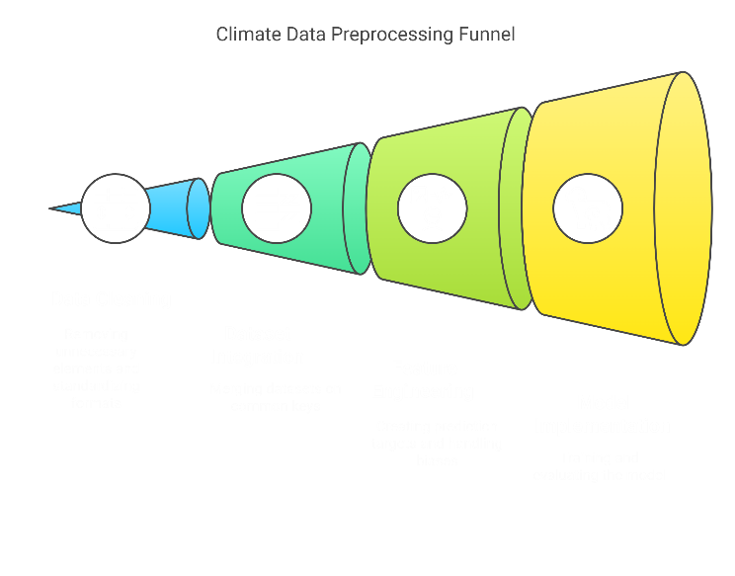

Through four crucial phases, the preprocessing pipeline gradually refines and integrates climatic data using a methodical funnel-based methodology. In order to eliminate superfluous columns and standardize formats, several CSV files containing climate and anthropogenic indicators (such as surface temperature changes, disaster frequencies, forest and carbon data, land cover accounts, sea levels, and CO2 concentrations) go through an initial cleaning process called Data Cleaning, which is the narrowest part of the funnel. The funnel continues into Dataset Integration, where label encoding for string variables is implemented, inner joins are used to preserve data consistency, and cleaned datasets are combined using common keys (Year, Country). By establishing prediction targets using n-year disaster data shifts, managing missing values using mean imputation, and eliminating bias columns and duplicates, the third stage, feature engineering, expands the scope even more. Model implementation is represented by the largest portion of the funnel, which includes correlation analysis, baseline Ridge Regression implementation, data splitting (70-30 ratio), and outlier treatment using the IQR method (k=1.2). With each step gradually improving and getting the data suitable for the ensuing attention-based LSTM architecture, this funnel-based method guarantees a methodical transition from raw data to datasets that are ready for modelling. The graphic successfully illustrates the methodical processing, integration, and refinement of various data sources through more thorough data preparation steps, culminating in a solid dataset appropriate for sophisticated climate disaster prediction modelling.

Model Architecture

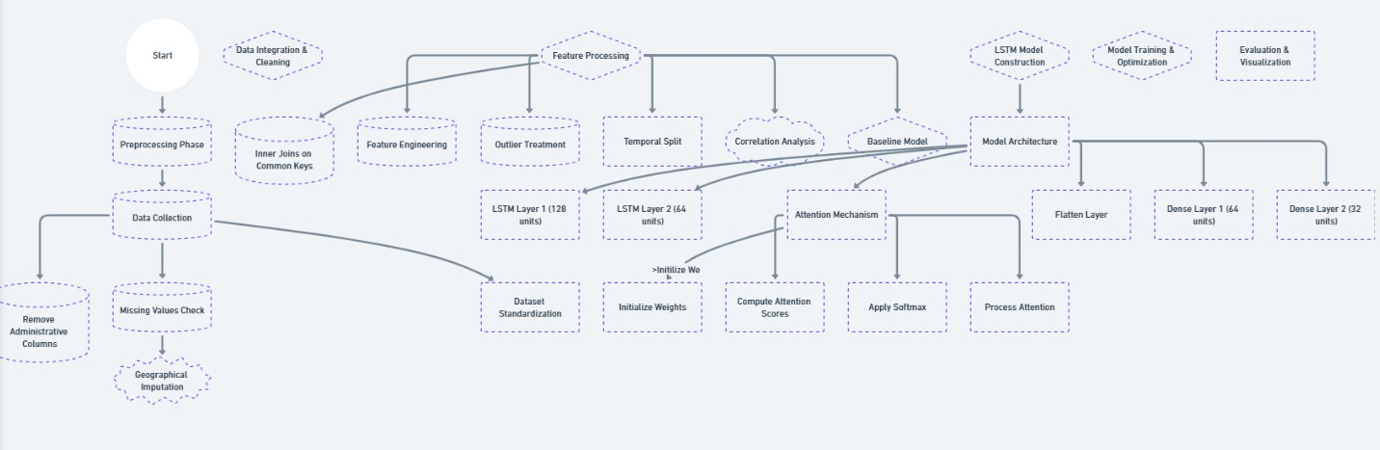

The system employs a thorough two-phase strategy to predicting climatic disasters. Starting with data collection and moving through administrative column elimination, missing value detection, and geographical imputation, the preparation phase adheres to a methodical decision-tree approach. Important choices for data standardization and cleaning are made during this phase, which ends with inner joins on shared keys that feed into concurrent feature engineering, outlier treatment, temporal splitting, correlation analysis, and baseline modelling procedures. The architectural diagram illustrates how an attention-based LSTM neural network architecture constructed through an organized series of layers after the preprocessing phase. Dual LSTM layers (128 and 64 units, respectively) are used to start the model construction process. LSTM Layer 1 starts with 64 units and sends its output to LSTM Layer 2 with return_sequences=True. The third diagram illustrates the intricate implementation process of the custom attention mechanism, which includes weight initialization, attention score calculation, and SoftMax application. Through initialization, calculation, and bypass stages, this attention layer calculates relevance scores across temporal steps using a trainable weight matrix. After a flatten layer and two dense layers (64 and 32 units) using ReLU activation, the design ends with a sigmoid output layer that can forecast six different sorts of disasters. Using early halting, model checkpointing and learning rate reduction techniques, the model is trained using the Adam optimizer (learning rate=0.001) with MSE loss function. A solid end-to-end system from data preparation to real-time prediction capabilities is created by validating the entire pipeline using thorough evaluation metrics (MAE, RMSE, and R2) and visualizing it using an interactive Streamlit dashboard. As demonstrated by the flowcharts, this integrated methodology guarantees both methodical data preparation and complex model implementation with transparent validation and visualization paths.

IMPLEMENTATION
After the theoretical outline of the proposed work. Now, will go towards the implementation phase where in 1st cycle obviously it will be data collection from International Momentary fund(IMF) and doing the Preprocessing and selecting all the feature required for our output variables because if talking about the climate and anthropogenic indicators that are essential for disaster prediction there are many but what is needed is choosing the most important factors.
Using the most efficient library like matplotlib for finding the top features required to our target variables.
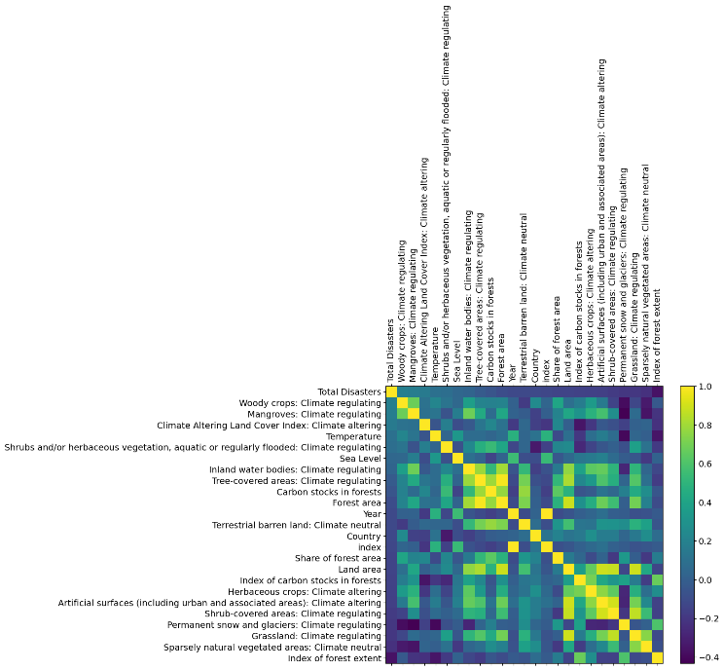

After selecting all the top features we took an even further step by checking the most required feature because the model will be more sustainable if took most important feature just like filtering out the feature that are less important by checking in correlation coefficient with all disasters which shows important feature with higher bar graph value.
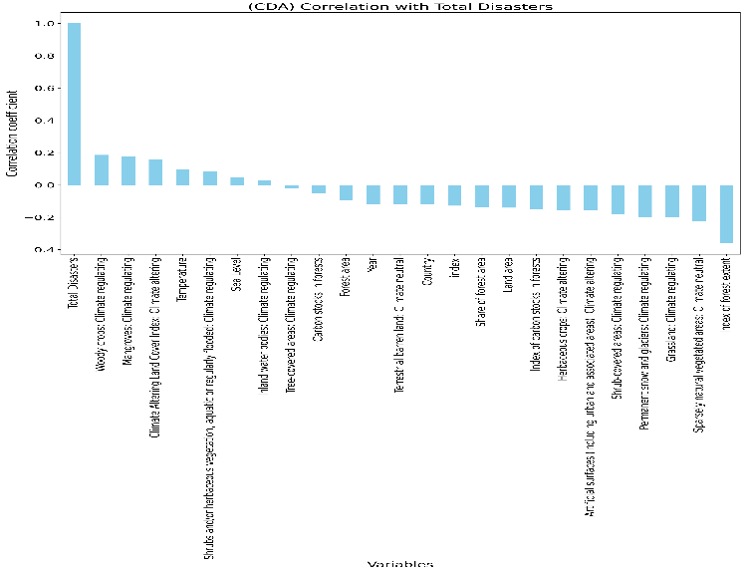
Following the selection of appropriate features now will remove outliers and all required work that is needed and merging all the separate datasets in single dataset which makes it easier by containing all data at single place and normalizing according to the country and each year
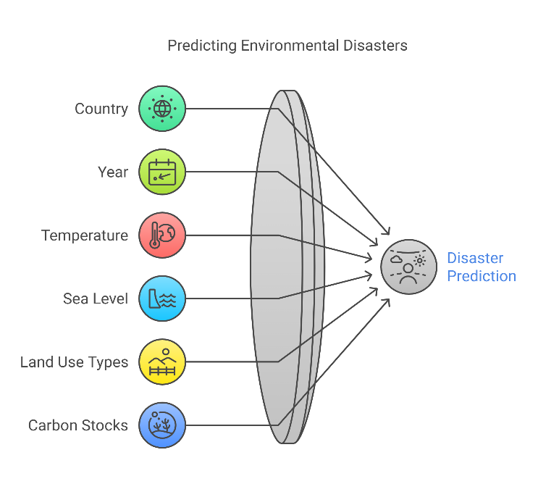

Now all the work related to data has completed and after the loading of this new data. Now moving on to see for few factor that had been taken for the target variable prediction is error free and there are no anomalies present in the new data

CO Percentage over time

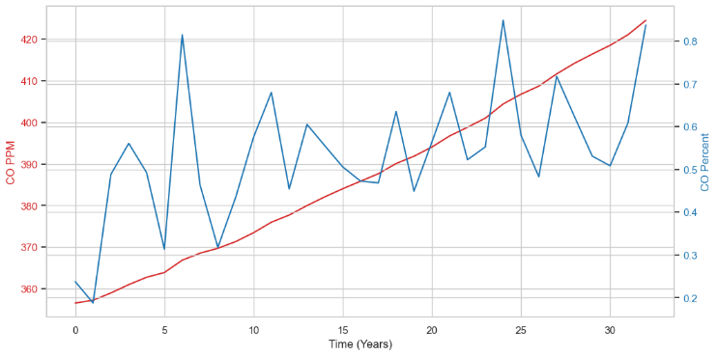

From the above pic seeing that anomalies is not present and there is continuous increase in CO evenly without any outliers which makes it suitable.

Sea Level Changes
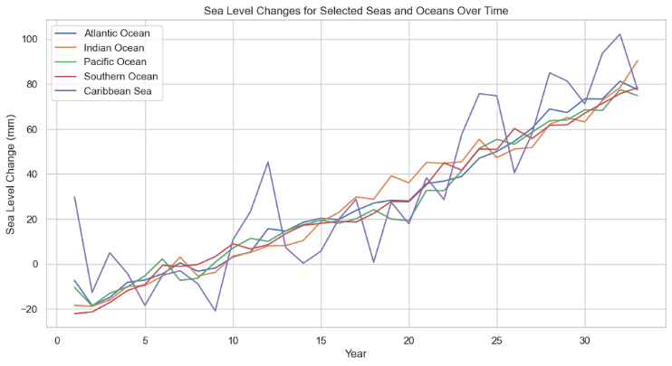
The sea level changes in most common sea’s which are responsible for wate disaster can be seen and the data has been continuously increasing.

Total Disasters over Time
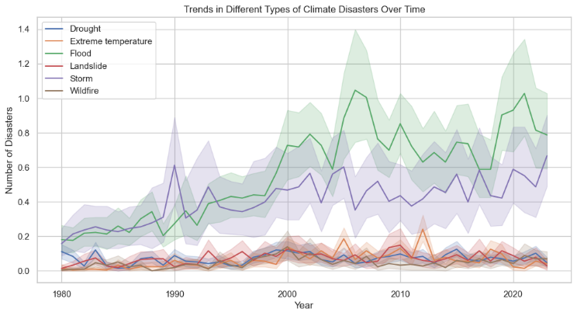
Since the model’s agenda is to give prediction about multiple natural hazards so it is obvious that based on data, fetched from IMF should perform the trend analysis in sequential time of the data.

RESULTS
After creation the model the most important aspect is checking the training of model and actual data is matching correctly with the predicted value of the model and if the training curves are not aligning then fine-tuning of the model is necessary.
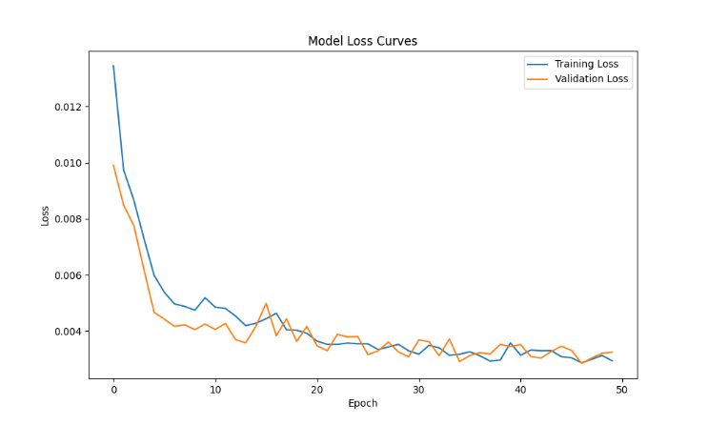
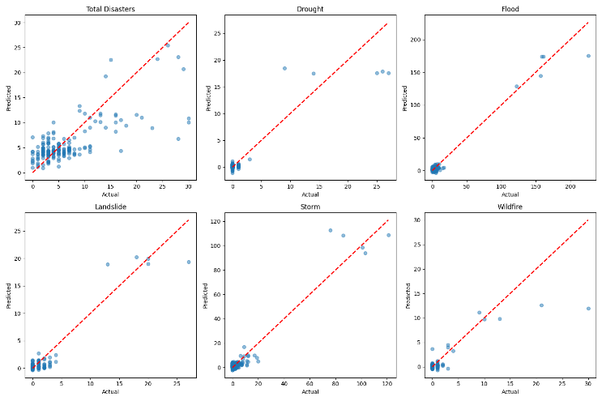
Upon deployment of the trained model using Streamlit which contains section of home page where selection of country and year is present and other tabs such as training metrics, data analysis shows stats and trend analysis of the model and data that is available.
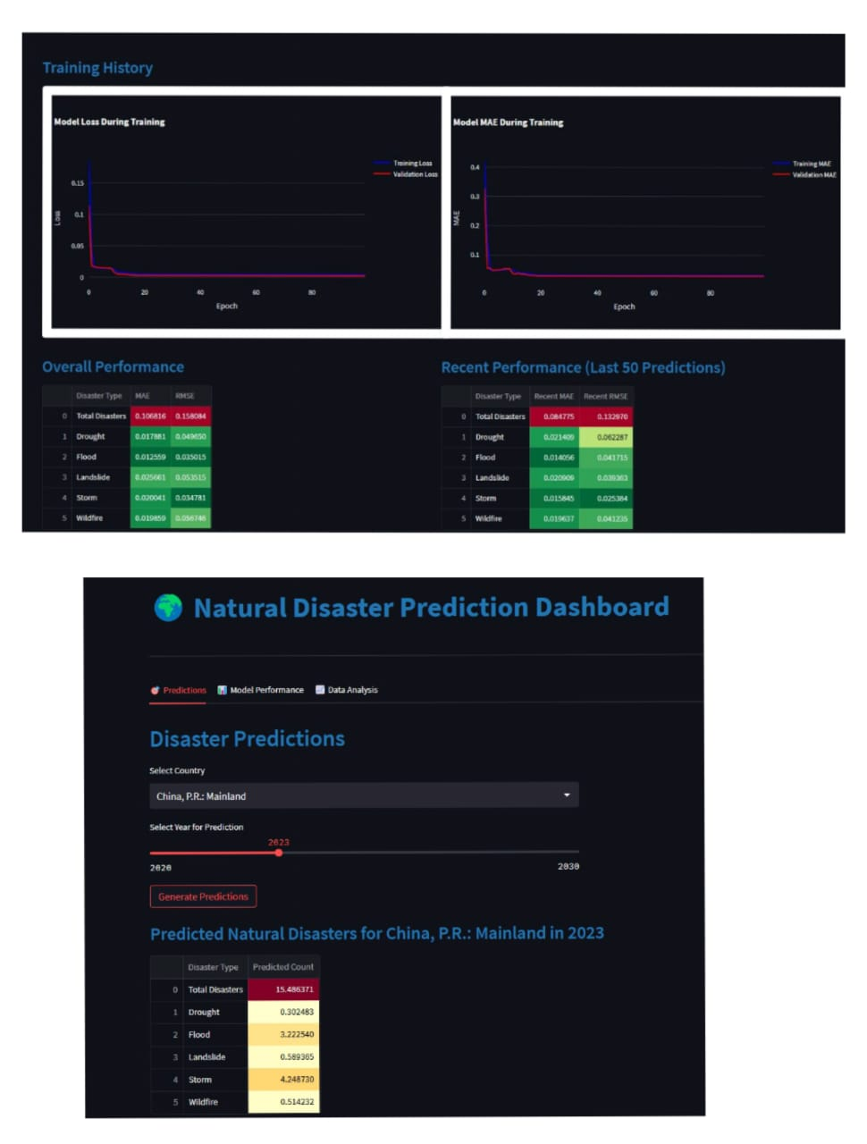

References
[1] G. Mahesh Vardhan Reddy, P. BharatwajTeja, K. Thirumala Devi, K. Rahul Dev, D. S. Kumar, and V. Phani Kumar Sistla, “Natural Disaster Prediction Using Deep Learning”, doi: 10.1109/ICCCIT.2025.58.
[2] C. Nandhakumar, J. MarkElfric, S. Maruthanayagam, G. Naveenkumar, and T. Sudharson, “Deep Learning for Disaster Detection: A Framework for Automated Multimodal Data Classification,” in 6th International Conference on Mobile Computing and Sustainable Informatics, ICMCSI 2025 - Proceedings, Institute of Electrical and Electronics Engineers Inc., 2025, pp. 1175–1179. doi: 10.1109/ICMCSI64620.2025.10883476.
[3] Y. Wang and Z. Gou, “Research on Intelligent Decision Support System for Meteorological Disaster Risk Assessment Based on Artificial Intelligence,” in 2025 Asia-Europe Conference on Cybersecurity, Internet of Things and Soft Computing (CITSC), IEEE, Jan. 2025, pp. 453–457. doi: 10.1109/CITSC64390.2025.00088.
[4] X. Y. Wan, Y. Song, and T. L. Lau, “Advances in Deep Learning for Earthquake Monitoring and Forecasting: Techniques, Applications, and Future Directions,” in Proceedings of the IEEE International Conference on Software Engineering and Service Sciences, ICSESS, IEEE Computer Society, 2024, pp. 69–73. doi: 10.1109/ICSESS62520.2024.10719051.
[5] P. Shetty, S. Varma, S. Tripathi, and C. Bhole, “Advancements in Disaster Prediction: A Systematic Review of Earthquake, Flood, and Cyclone Forecasting Techniques,” in 4th International Conference on Sustainable Expert Systems, ICSES 2024 - Proceedings, Institute of Electrical and Electronics Engineers Inc., 2024, pp. 1665–1673. doi: 10.1109/ICSES63445.2024.10763136.
[6] H. Joshi, Nokshi, R. Chauhan, R. Rawat, and R. Gupta, “Climate Change: The Impact and Exploring The Path Forward,” in Proceedings of the 2nd International Conference on Intelligent and Innovative Technologies in Computing, Electrical and Electronics, ICIITCEE 2024, Institute of Electrical and Electronics Engineers Inc., 2024. doi: 10.1109/IITCEE59897.2024.10467588.
[7] J. Arora, P. Khullar, A. Saini, R. Sharma, and G. Sharma, “Real-Time Weather Data Analysis for Disaster Management and Response,” in 2024 1st International Conference for Women in Computing, InCoWoCo 2024 - Proceedings, Institute of Electrical and Electronics Engineers Inc., 2024. doi: 10.1109/InCoWoCo64194.2024.10863368.
[8] K. Li, B. Yang, and L. Yang, “Drought Prediction Using SVM, Naïve Bayes and LSTM Recurrent Neural Network,” in Proceedings of the 35th Chinese Control and Decision Conference, CCDC 2023, Institute of Electrical and Electronics Engineers Inc., 2023, pp. 2715–2720. doi: 10.1109/CCDC58219.2023.10326890.
[9] Z. Su and Q. Zhang, “Earthquake prediction based on Bi-LSTM+CRF model and Spatio-Temporal Data,” 2020, pp. 1190–1195. doi: 10.1109/ITAIC49862.2020.9339192.
[10] K. M. A. Hassan, M. A. Haque, and S. Ahmed, “Comparative Study of Forecasting Global Mean Sea Level Rising using Machine Learning,” in Proceedings of International Conference on Electronics, Communications and Information Technology, ICECIT 2021, Institute of Electrical and Electronics Engineers Inc., 2021. doi: 10.1109/ICECIT54077.2021.9641339.
[11] A. Bangar, S. Ansari, S. S. Ali, V. Baderao, and B. Alhat, “Disaster Prediction Using Appropriate Machine Learning Techniques,” in 2024 IEEE Pune Section International Conference, PuneCon 2024, Institute of Electrical and Electronics Engineers Inc., 2024. doi: 10.1109/PuneCon63413.2024.10895154.
[12] G. Gursoy, A. Varol, and A. Nasab, “Importance of Machine Learning and Deep Learning Algorithms in Earthquake Prediction: A Review,” in ISDFS 2023 - 11th International Symposium on Digital Forensics and Security, Institute of Electrical and Electronics Engineers Inc., 2023. doi: 10.1109/ISDFS58141.2023.10131766.
[13] A. Shameem, D. Saroja, D. S. Hotkar, B. B. Nayak, A. Pandey, and S. Tripathi, “AI for Disaster Management: Predictive Models and Response Strategies,” in 2025 International Conference on Pervasive Computational Technologies (ICPCT), IEEE, Feb. 2025, pp. 798–801. doi: 10.1109/ICPCT64145.2025.10941459.
[14] F. Ahmad, M. Tarik, M. Ahmad, and M. Z. Ansari, “Weather Forecasting Using Deep Learning Algorithms,” in 2023 International Conference on Recent Advances in Electrical, Electronics and Digital Healthcare Technologies, REEDCON 2023, Institute of Electrical and Electronics Engineers Inc., 2023, pp. 498–502. doi: 10.1109/REEDCON57544.2023.10150439.
[15] K. Sahu, I. Bhardwaj, V. Sharma, S. Mishra, and M. I. Habelalmateen, “Sustainable driven Predictive Approaches to Address Climatic Crisis: Issues and Challenges,” in International Conference for Technological Engineering and its Applications in Sustainable Development, ICTEASD 2023, Institute of Electrical and Electronics Engineers Inc., 2023, pp. 362–368. doi: 10.1109/ICTEASD57136.2023.10584934.

